Satphere App – Introduction
Satphere is a modern matrimonial platform designed to help people find their perfect match with trust, comfort, and convenience.
It combines powerful matchmaking tools with smart technology, making the partner-search journey smooth and meaningful.
With Satphere, users can explore verified profiles, connect instantly through chat, and build real relationships using voice and video calls.
The app also includes an advanced Kundali Matching system, helping users and families check compatibility before taking the next step.
From discovering matches to communicating with them personally, Satphere brings everything together in one safe and user-friendly app — making the search for a life partner simple, secure, and truly enjoyable.

🔐 Login Screen Content
Welcome Back to Satphere
Find your perfect match and continue your journey with us.
Login to your account
Enter your registered mobile number or email to access your profile, explore matches, and connect instantly.
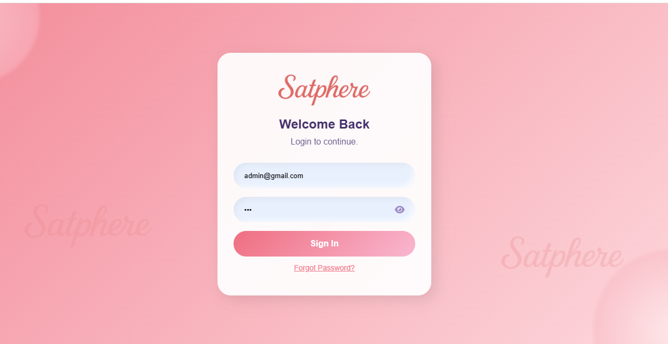

🔁 Forgot Password Screen Content
Forgot Your Password?
Don’t worry — it happens to everyone.
Enter your registered mobile number or email, and we’ll send you a verification code to reset your password securely.
Recover your account
Follow the simple steps and get back into your Satphere profile within seconds.
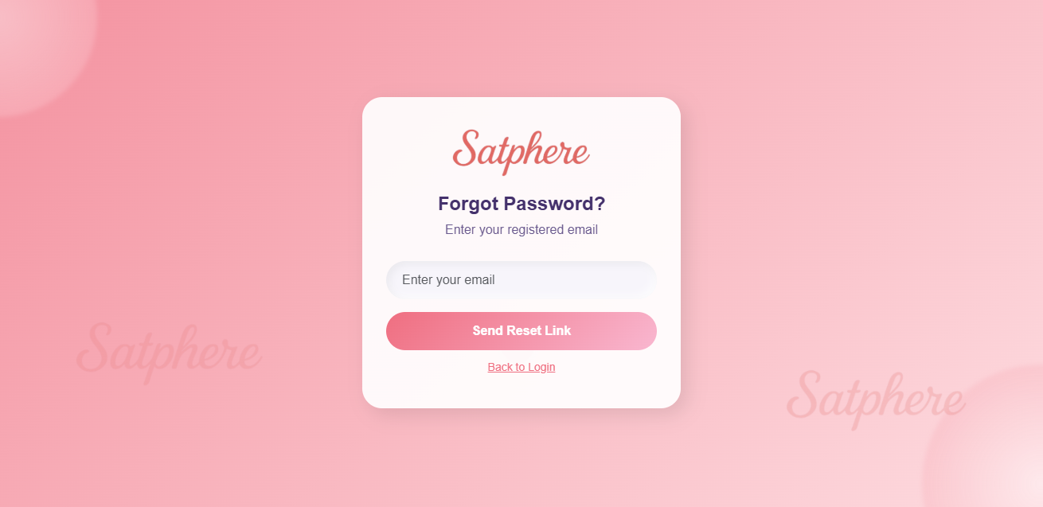

1. Dashboard
"The dashboard gives you a complete overview of the system. You can quickly see total users, deposits, subscriptions, and other daily statistics in one place."
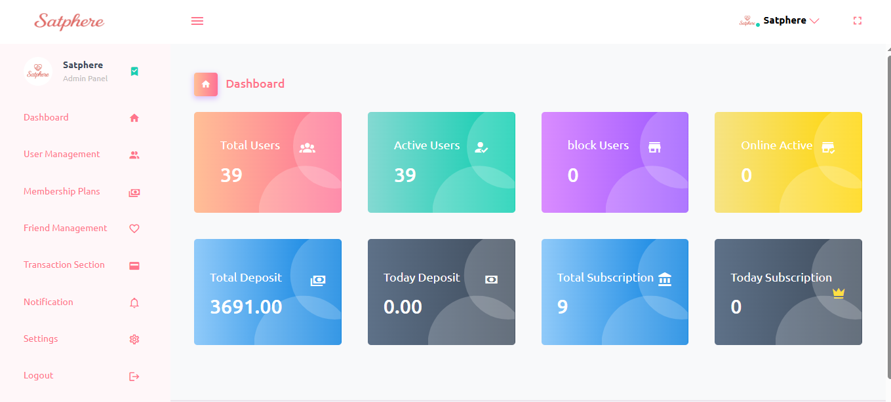

2. User Management
"In this section, you can manage all users — view the list, add new users, edit details, and block or unblock accounts. It helps you control the entire user base easily."

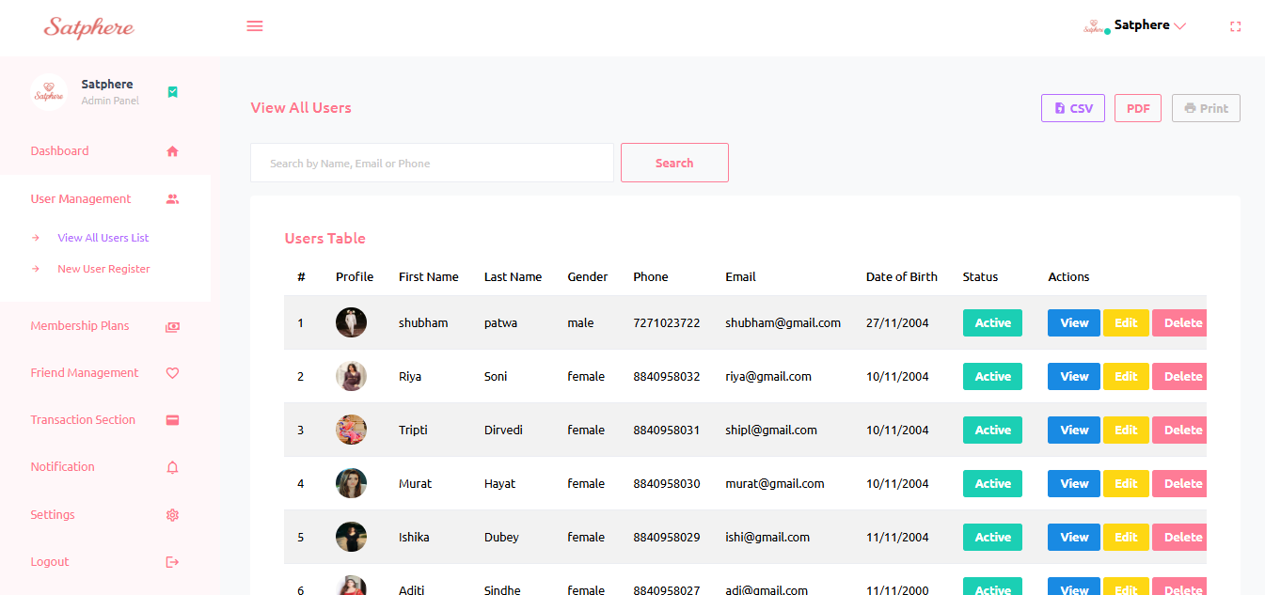
Create Your Satphere Account
Join India’s most trusted matrimonial platform designed to help you find a meaningful connection.
Start your journey
Enter your basic details to create your profile and explore verified matches, kundali compatibility, audio/video calls, and secure chat features.
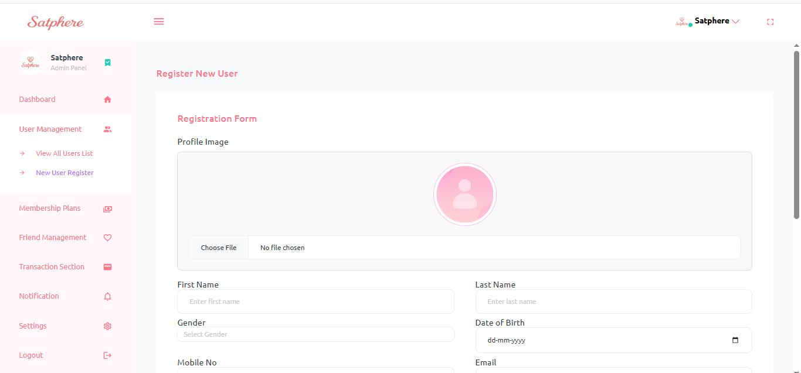

3. Membership Plans
"Here you can create and manage membership plans. Update pricing, validity, and plan features, and monitor all user subscriptions from this section."
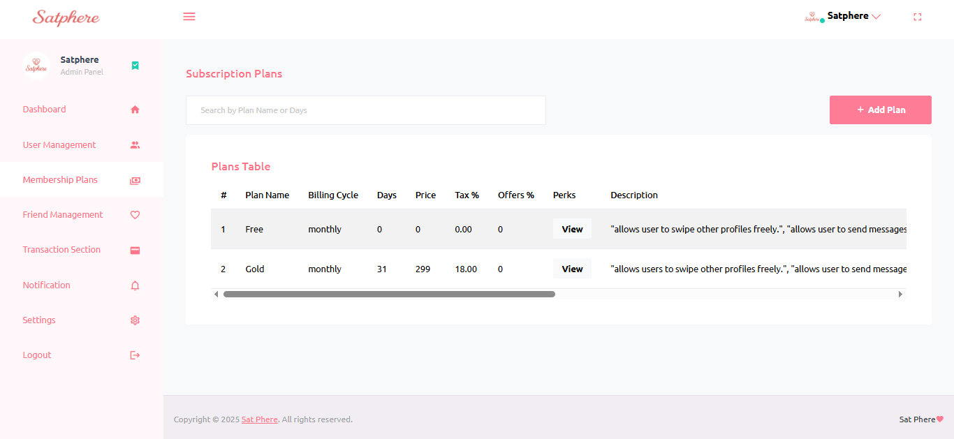
Membership Plans Edit
Update Plan Details
Modify the pricing, duration, and features of this membership plan. Make sure all information is accurate so users get the correct benefits.
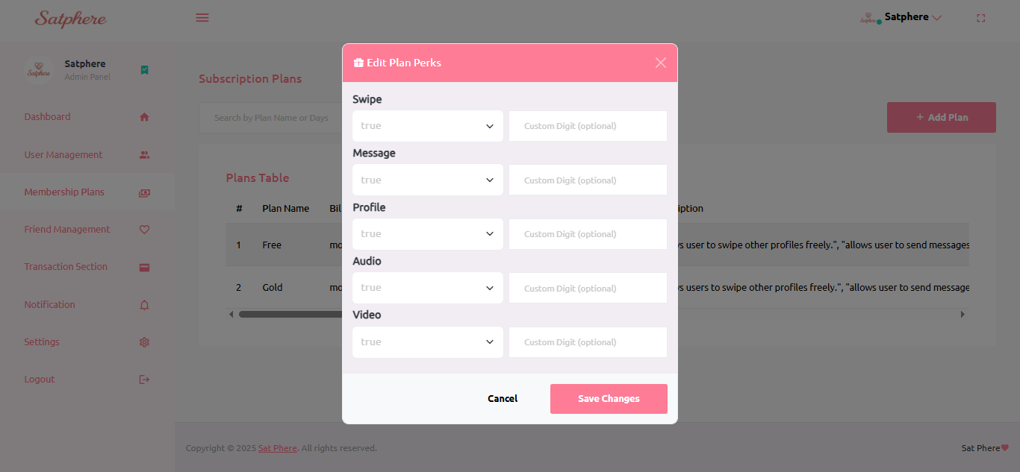
Membership Plans Add
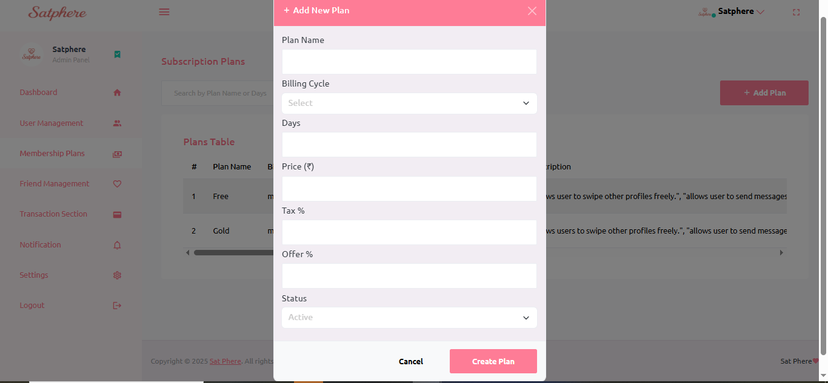

4. Friend Management
"This section lets you track user connections and friend activities. It helps manage how users interact and connect with each other in the system."
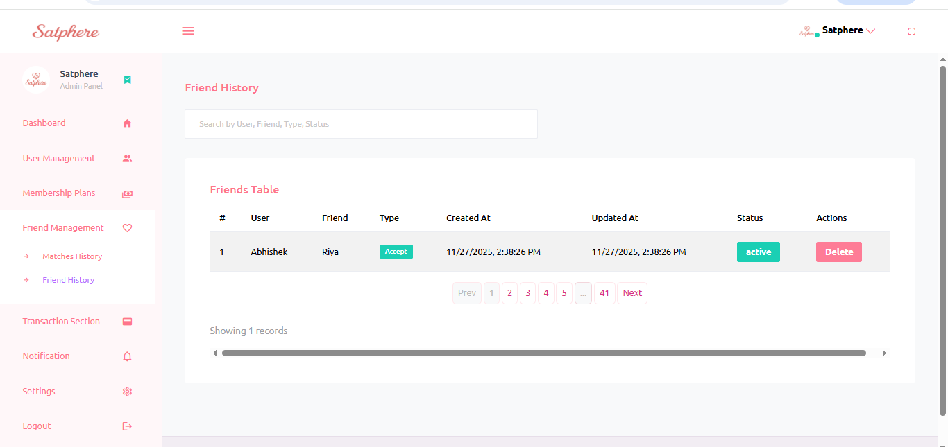

5. Transaction Section
"Track all deposits, withdrawals, and payment history here. It provides a clear view of the financial activity happening across the platform."

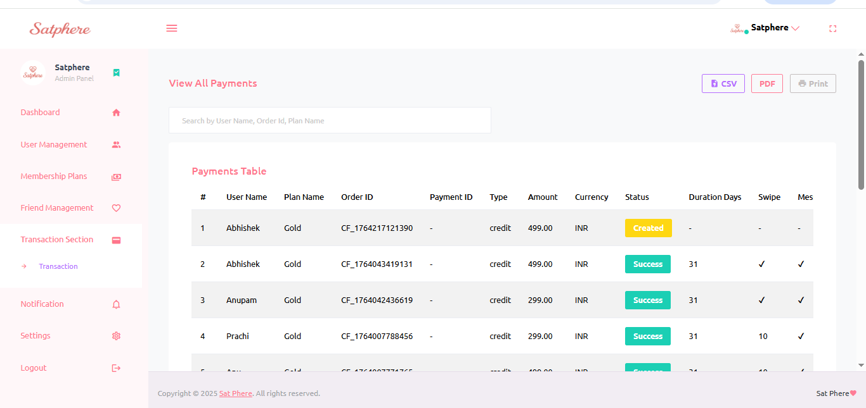
User Plan Edit
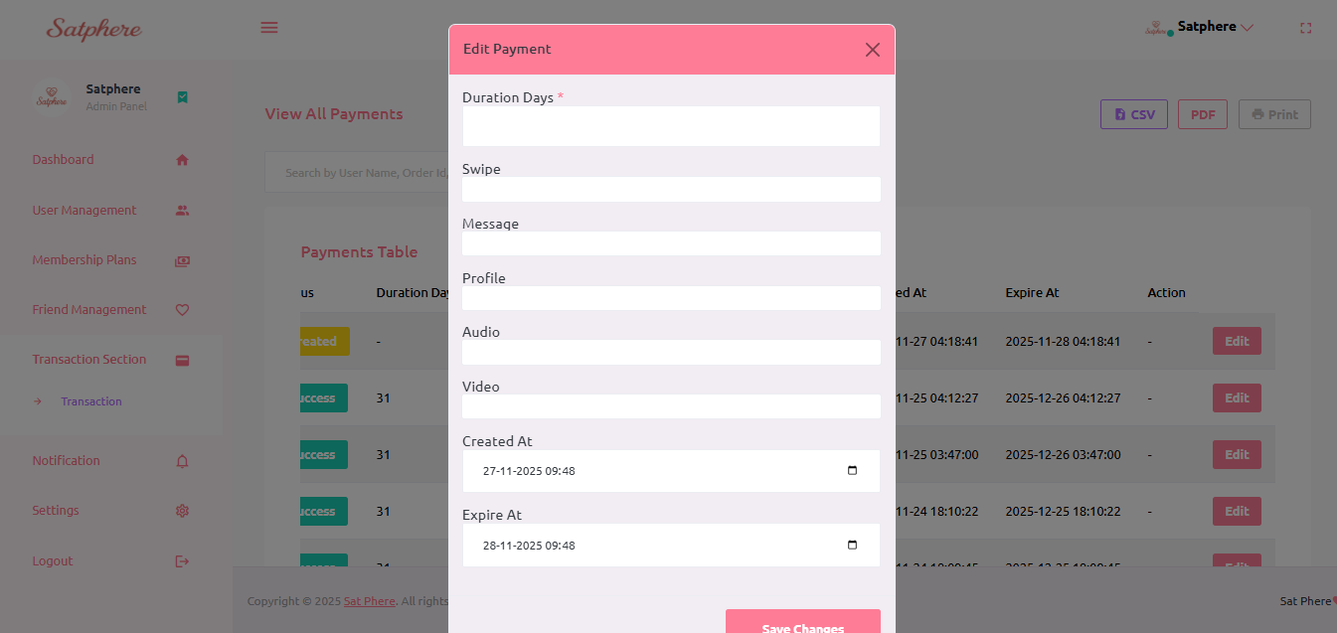

6. Notification
"Send push notifications to all users directly from this panel. Share important alerts, updates, offers, or messages instantly with your audience."

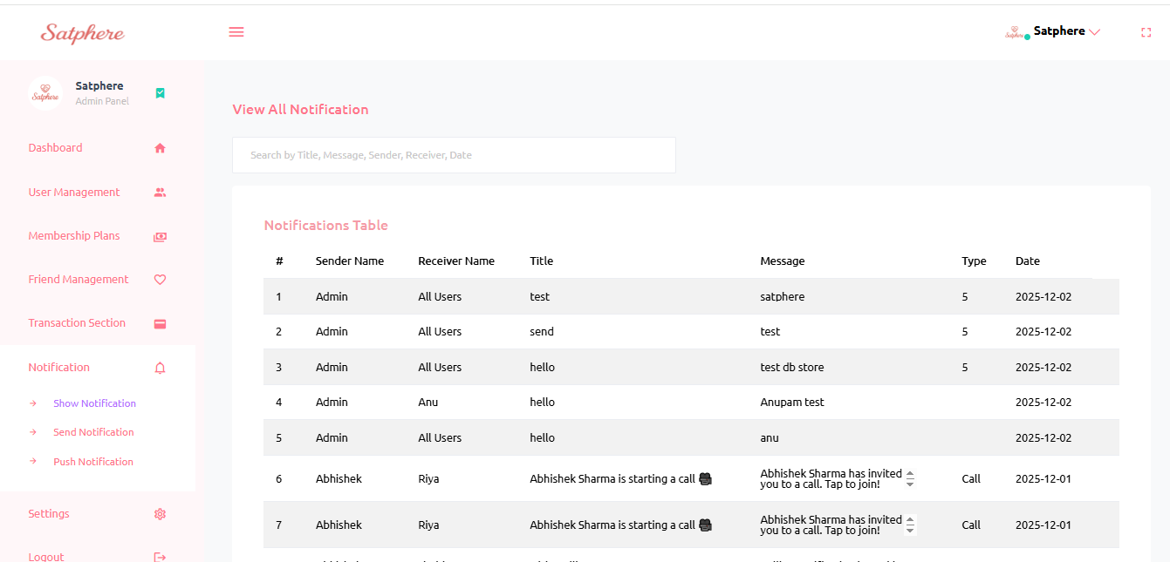
Notification Send to All users
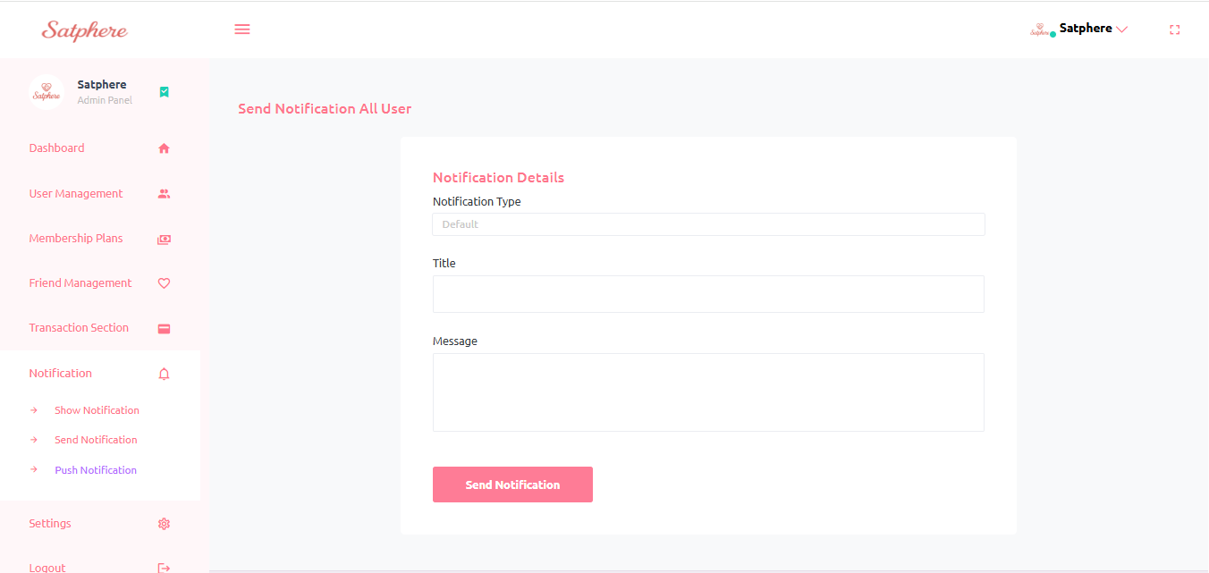
Send Notification To Seleted Users
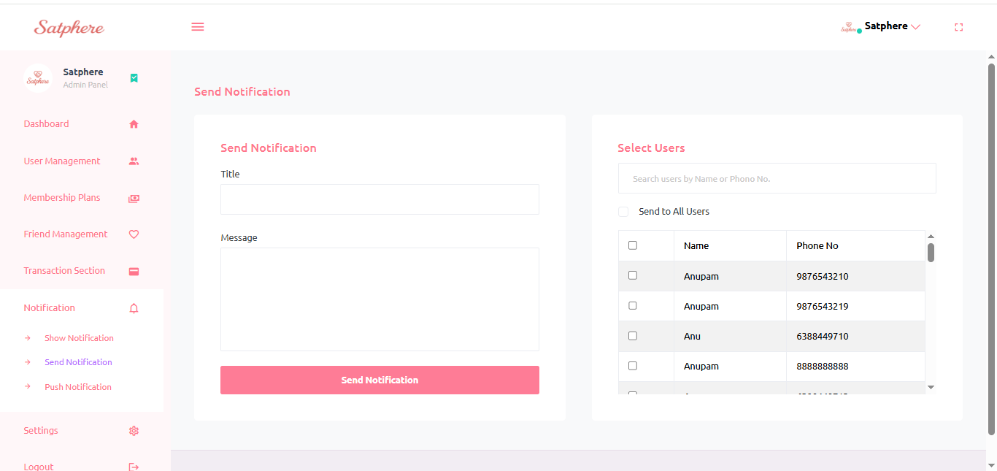

7. Settings
"Manage important system configurations here — including Lists, support settings, theme options, and general system preferences."
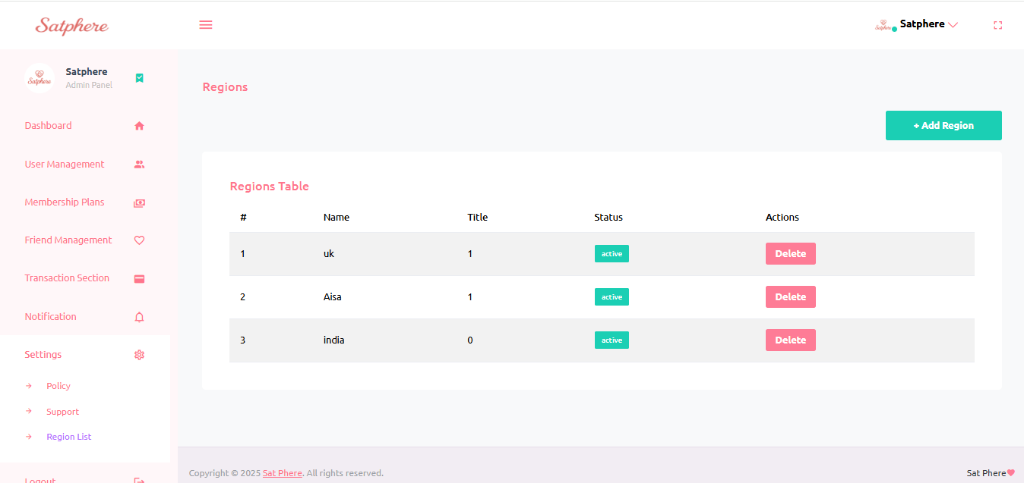
Support
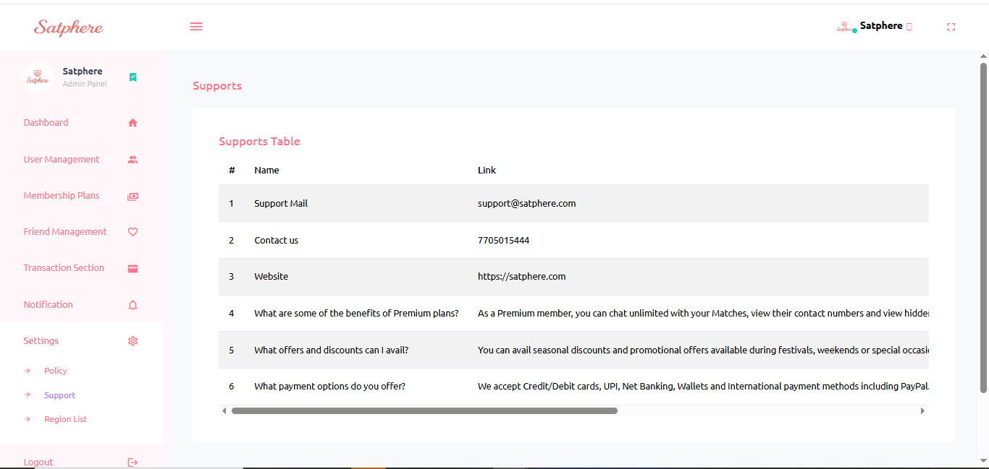

Policy Section Overview (English Description)
Our platform includes three important policy pages to ensure transparency, trust, and clarity for all users. These pages outline how our services work, how we protect user data, and under what conditions refunds are provided. Each policy is designed to give users a safe and reliable experience.
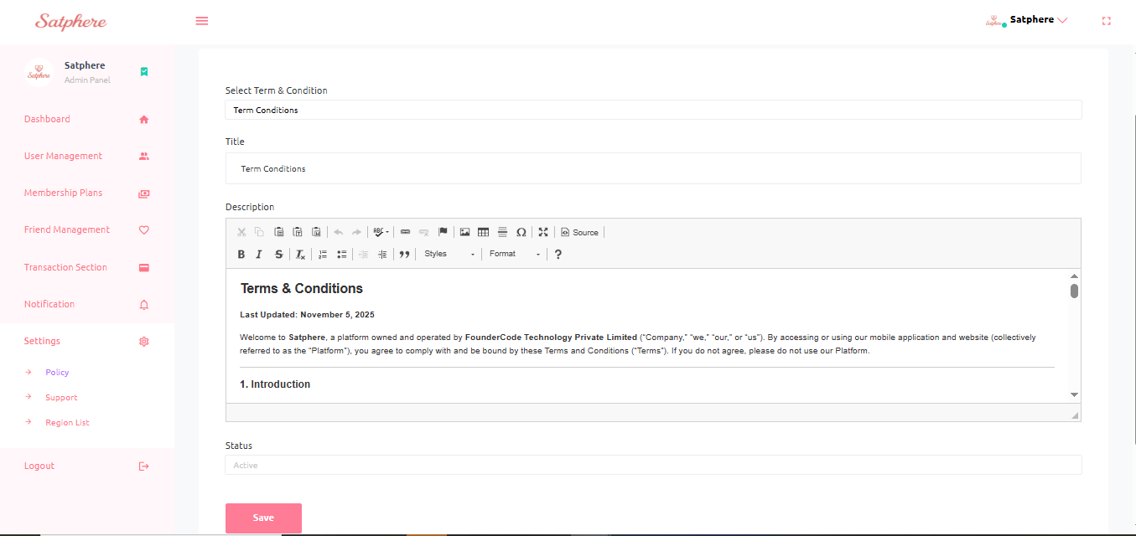

8.Admin /Password
The Admin Profile section allows the admin to manage their account details. Here, the admin can easily update their email, change their password, and upload a new admin logo. This helps maintain security, keep information up-to-date, and manage branding in the dashboard.
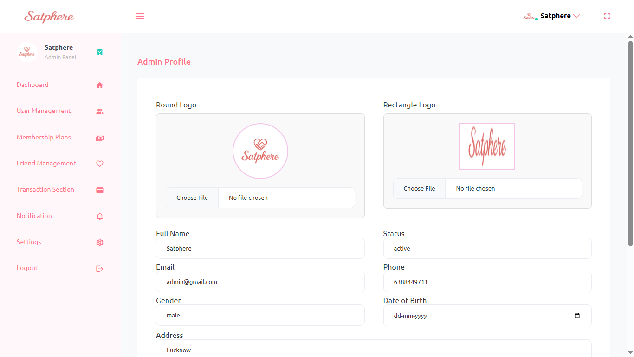

Logout
"Securely sign out from the admin panel. Use this option to end your session and protect your account."
Thank You

